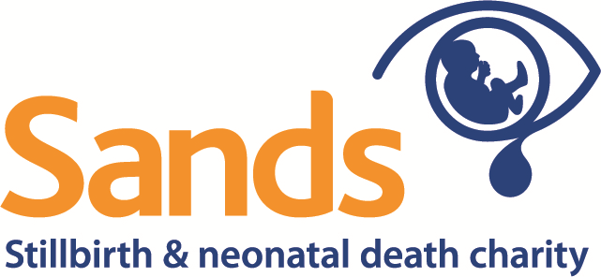

Sands, the stillbirth and neonatal death charity
Perinatal Expert Panel
Terms of Reference

Sands’ Perinatal Expert Panel (PEP) has been established to provide independent review of applications for research funding and make recommendations to Sands Research Subcommittee and Board of Trustees for allocation of research funds. The PEP will also advise Sands, on an ad hoc basis, on matters of science that may affect Sands’ position and strategy. All members of the Sands PEP are expected to abide by Sands’ Conflicts of Interest policy.

Role
  - A subgroup of the PEP will triage initial outline applications to remove poor-quality applications. The PEP Chair reserves the right to suggest improvements to a low-scoring application and recommend that a full application be submitted.
  - As a Group, the PEP will:
    - discuss and score applications against an agreed framework in order to inform the subsequent selection of proposals by the Research Subcommittee and Board
    - advise Sands on scientific matters that may affect Sands’ position and/or strategy
    - advise on the evaluation of funded studies if requested.
  - Individually, PEP members may be asked to:
    - act as named lead reviewers for individual proposals, leading discussion on the project and peer review outcomes to the PEP for consideration, and giving applications indicative scoring
    - advise Sands on scientific matters within their area of expertise.

Working arrangements
  - The PEP will meet once a year and will make formal recommendations on proposed grants to the Research Subcommittee and Board of Trustees.
  - The decision of the Board of Trustees about applications is final. Feedback will be provided to applicants.
  - Sands’ Research and Prevention team will support the PEP and act as the point of liaison between the PEP and the Research Subcommittee/Board.

Membership
  - The Board of Trustees will appoint the Chair of the PEP. A Vice Chair will be nominated by the Chair and agreed by the PEP. Appointments of the Chair, Vice Chair and all members will be renewed every 3 years, with one 3-year renewal possible, but with some staggering of rotation to avoid loss of continuity and consistency. Additional Board members can be co-opted depending on relevant skills and expertise, and the membership will be reviewed by the Chair on an annual basis.
  - The PEP should have no fewer than five members. Membership of the PEP can be changed at any time according to the discretion of the Board of Trustees.
  - For reasons of practicality and expertise, initial membership will be drawn largely or entirely from the Stillbirth Clinical Studies Group.
  - The membership of the Sands PEP will be published on the Sands website.

Conflict of Interests
  - Sands’ Conflicts of Interest: Research Funding policy sets out the procedures that will be adopted to reduce the risk of a conflict arising.
These terms of reference were agreed by the Sands Board of Trustees in May 2016

