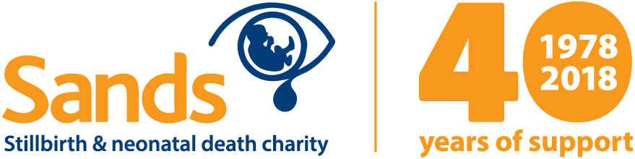

PRESS RELEASE
[INSERT DATE]

[NAME] Sands group to commemorate the charity’s 40th anniversary
[NAME] Sands group will be commemorating the 40th anniversary of Sands (Stillbirth and neonatal death charity) by holding a thank you [PICNIC/BAKE SALE/BARBECUE/COFFEE MORNING/LUNCH/OTHER EVENT].

Everyone is welcome to attend the [PICNIC/BAKE SALE/BARBECUE/COFFEE MORNING/LUNCH/OTHER EVENT] that will be held on [DATE, LOCATION AND TIME], to recognise people locally who have made Sands such a success over the past four decades.

This year, the charity is recognising the support of volunteers, befrienders, fundraisers, healthcare professionals (including midwives) for their contributions towards Sands’ aims to support anyone affected by death of a baby over the past 40 years across the UK.

The Sands 40th anniversary is also a way to acknowledge the charity’s impact on the lives of many bereaved parents, improvements in bereavement care and funding vital research to help reduce the number of babies dying.

[FIRST NAME AND SURNAME], Chair of the [NAME] Sands group, said: “Many members of our group are bereaved parents so we know how devastating it is when a baby dies – whether recently or long ago. Our group has supported many bereaved parents in the past and will continue to do so for as long as they need us.

“Sands’ 40th anniversary is a great opportunity to raise awareness of the help and support available and to recognise the contribution of the many volunteers that make the charity what is it today. I hope as many people as possible will join us at our [NAME OF EVENT].”

Sands is at the heart of supporting bereaved parents and the local support groups which are situated across the UK.

Sands groups are run on a voluntary basis by people who have themselves experienced the death of a baby.

[NAME] Sands group meets on [DAY/DATE OF THE MONTH] from [START AND FINISH TIME] at [LOCATION] and newly and long ago bereaved parents and their families are more than welcome to attend. For further information call [NAME, PHONE NUMBER AND EMAIL ADDRESS].

For further information on Sands’ 40th anniversary visit:

www.sands.org.uk/about-sands/40th-anniversary

-Ends-
Notes to editors
For further information, please contact Lee Armitt, Press and PR Officer on 020 3897 3449/07587 925411 or media@sands.org.uk

Sands’ history
In the mid-1970’s two women – Hazelanne Lewis, a psychiatric social worker, and Bel Mooney, a journalist – both gave birth to stillborn babies. At that time, most parents were not allowed to see or hold their babies, no pictures were taken and they were not told where their babies were buried.

Using her professional standing to break the silence around baby loss, Bel wrote a story for The Guardian describing her own experience, while Hazelanne wrote to national newspapers asking bereaved parents to share their stories. The avalanche of replies from all over the UK revealed the vast, unrecognised need for support and advice for bereaved parents and their families upon the death of their baby.

These two women sparked the discussion of the many difficulties in overcoming prejudice against openly acknowledging the death of a baby and the pain of bereavement. As a result, the National Stillbirth Study Group was set up in 1977, comprising of various health professionals and representatives from other bereavement support groups, who produced an information booklet for bereaved parents. It was this impetus that would form Sands.

About Sands
Sands is the leading stillbirth and neonatal death charity in the UK. They work nationally to reduce baby deaths through promoting better maternity care and funding research. They have a programme of training and a wide range of resources designed to support professionals to improve the bereavement care they provide following the death of a baby, and they provide a comprehensive bereavement support service both nationally through their helpline and locally through around 100 regional support groups based across the UK.

Further information can be found at www.sands.org.uk

